Paper Based Graphine Humidity sensor
Sensor Design:
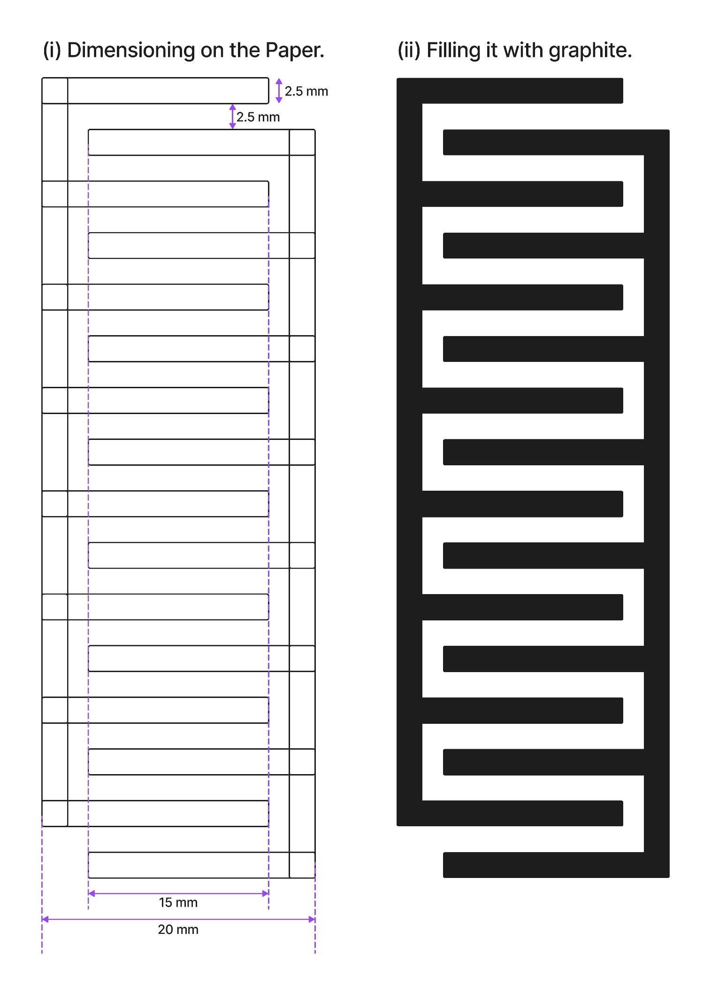

Maintained Standers:
- Filter Paper type:
- Hand Made Paper
Thickness: ranges from 0.12 to 0.5 mm. (Exact thickness is not mentioned)
Higher porosity and irregular fibre structure.
- Normal Paper
Thickness: ranges from 0.17 to 1.00 mm. (Exact thickness is not mentioned)
Smoother surface and consistent fibre distribution.
- Pencil Grade for graphite deposition: 10b
- Sensor Resistance: Ranging between R₀ = 40k ohm to 70k ohm
- Heat Pad:
- Material: 11 micron thick Aluminium Foil.
- Pattern: Serpentine.
- Power: 5.12 volt /
- Circuit: A voltage divider circuit kept in use with Arduino Uno to measure ADC values.
- Humidity Standers: market available DHT 11 sensor working range between 40% to 100% RH.
- Graph Plotting Method:
- Normal DHT 11 data plots + Best Fit Curve.
- Paper Sensor value → Reversed → Averaged of 10 values (to reduce the notice in the signal) → Plot + Best Fit Curve
Findings:
- Without heat pad:
- It works properly 1 time, after that the paper starts deforming and the Resistance increased above 1M ohm which produce garbage value and error in the signal.
- Paper Sensor with Heat pad:
- Heats the paper while Humidity is decreasing 100% to 50%
- It works properly around 3 time, after that the paper doesn’t deform due to the applied heat but the Resistance still increased above 1M ohm which produce garbage value and error in the signal.
- The Hand made paper giving a sharp humidity rise from 50 % to 100% (which drops the ADC value rapidly) also shows graphene deformation faster (increases resistance faster than the other one).
- Normal Paper shows slow humidity increase rate from 50% to 80% as compared to the hand made paper after that touches 100% faster. shows slow graphene deformation compared to hand made one.
- The Normal Paper is not capable of detecting slight increase in humidity at initial state which is important for measuring humidity from body (Nose).
Issues
- Graphite trace degradation over time due to moisture absorption and physical breakdown.
- Paper deformation under repeated humidity cycles even with heat applied.
- Inadequate control over heating profile, leading to inconsistent recovery.
Questions:
- Changing paper thickness, ranging between the hand made and the normal one.
- Using metallic ink or graphene ink to reduce the deformation rate to use the sensor for long time.
- Changing the ration of NaCl solution.
- Apply the heat in a measured way to control it.
- Changing the heat pad material paper to Kapton tape. Helps to apply more heat
- Changing the heat pad pattern or changing the material to increase the resistance.
- Reducing the gap between the paper sensor geometry.

Graphs:
- Without Heat Pad:
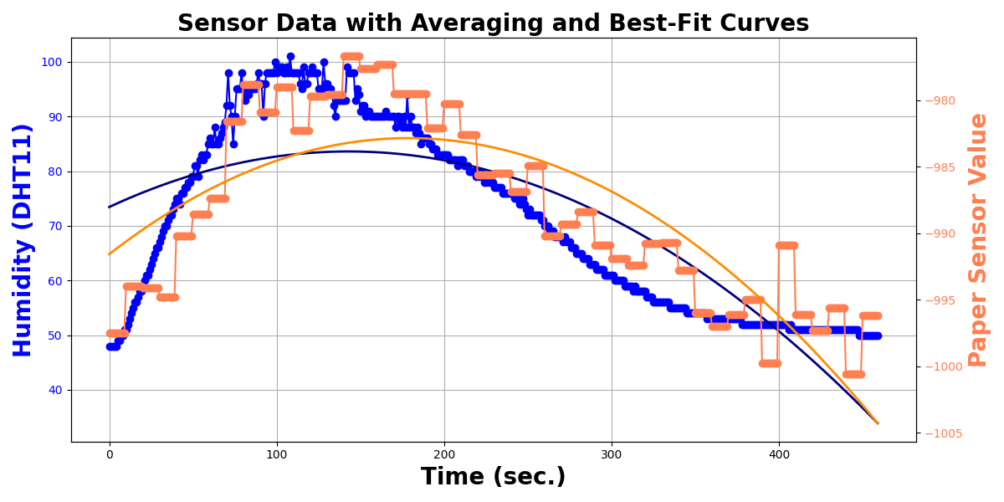
- Test 1: (Normal Paper)
- Test 2: (Normal paper)
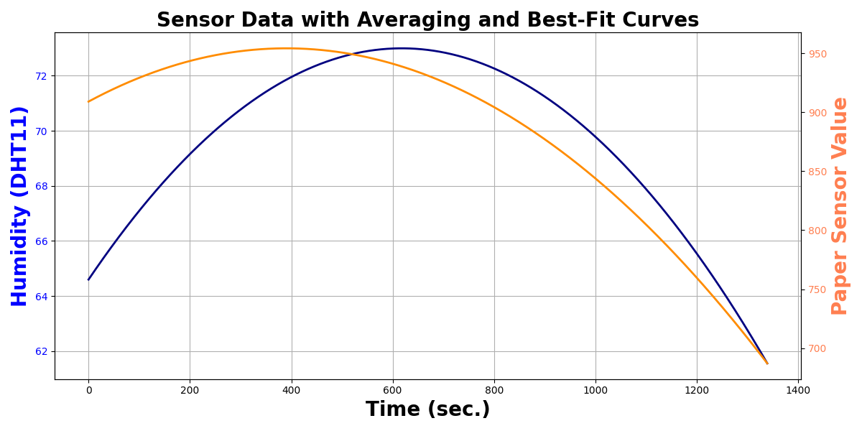
- Test 3: (Normal paper)
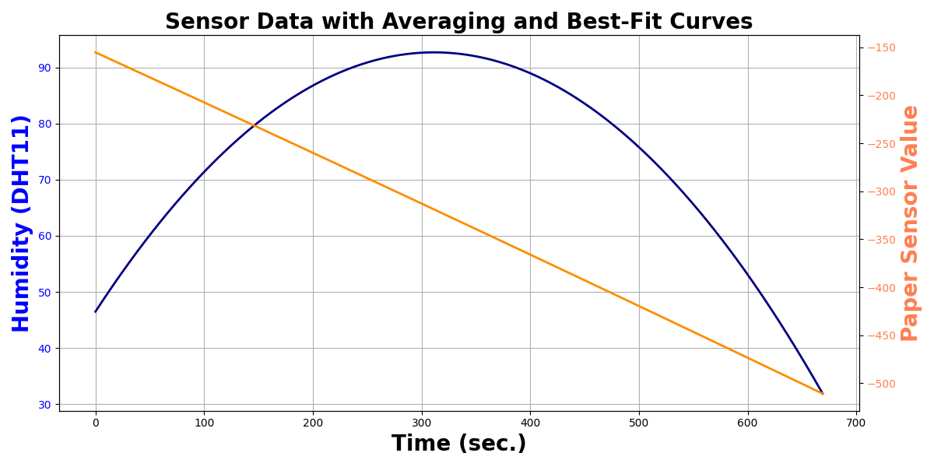
- Test 1: (Hand Made paper)
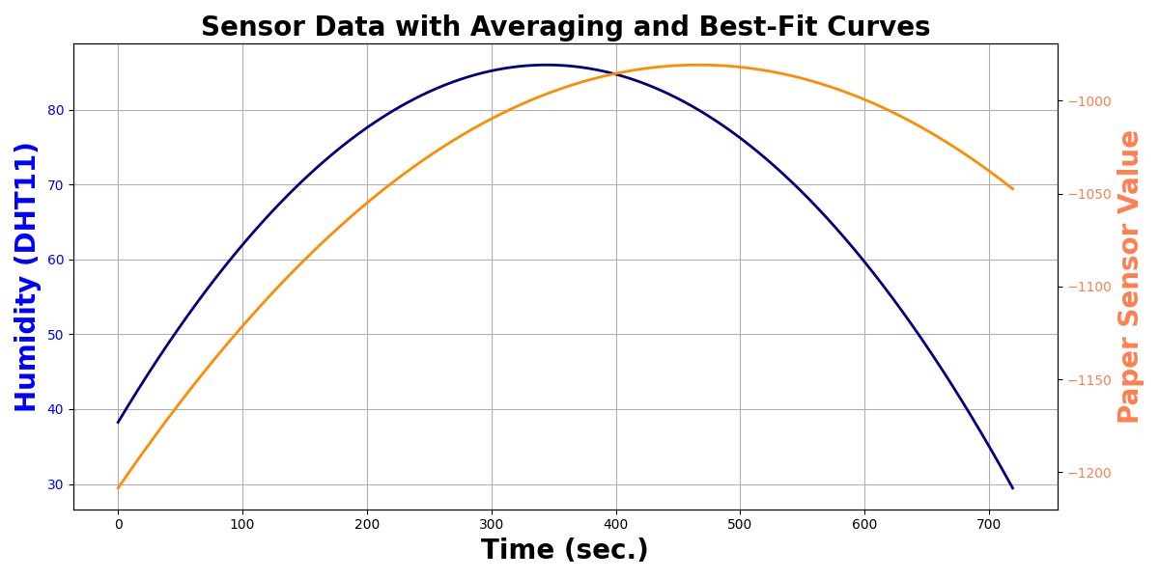
- Test 2: (Hand Made paper)
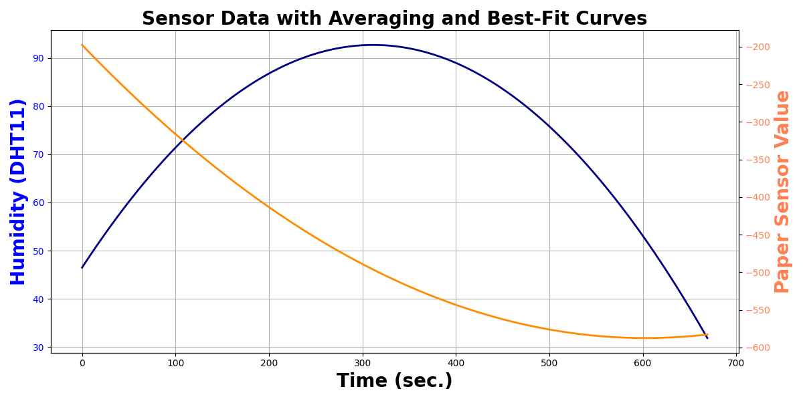

- With Heat pad:
- Test 1: (Normal paper)
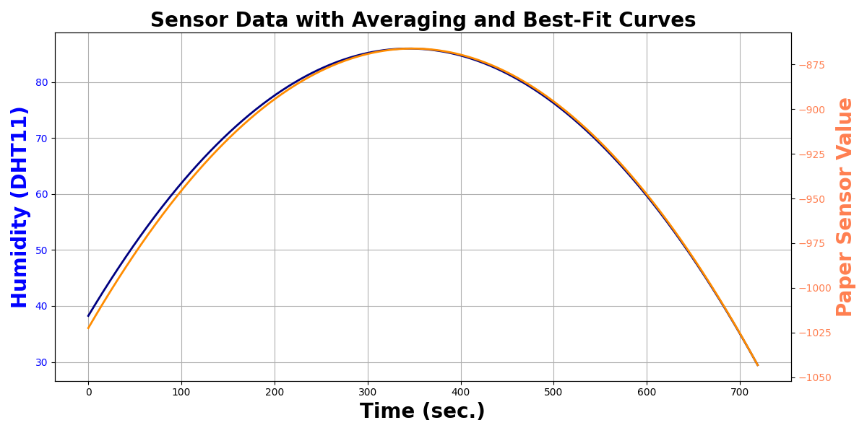
- Test 2: (Normal paper)
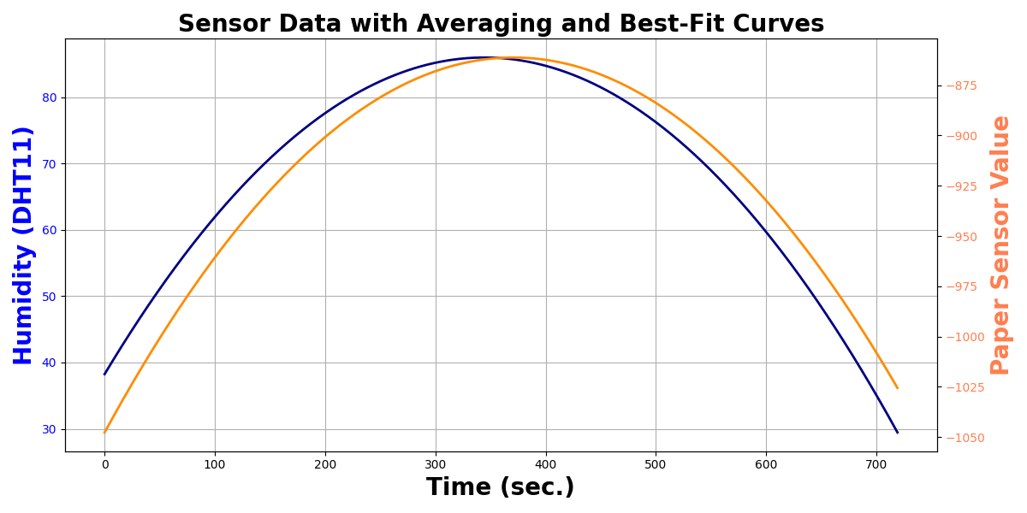
- Test 3: (Normal paper)
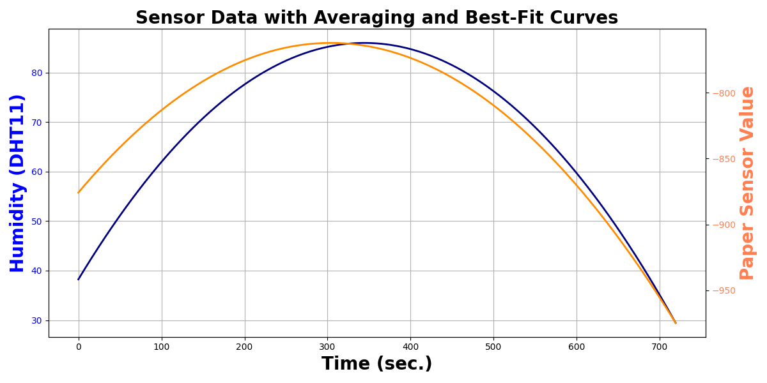
- Test 4: (Normal paper)
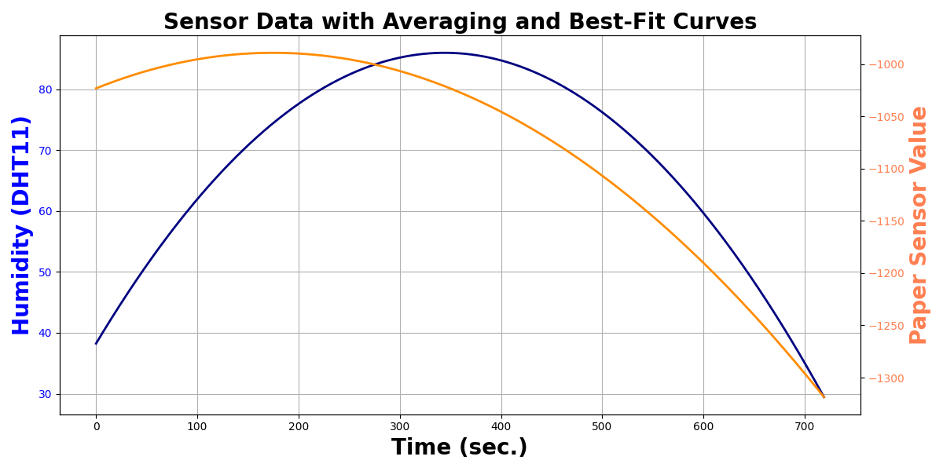
- Test 1: (Hand Made paper)
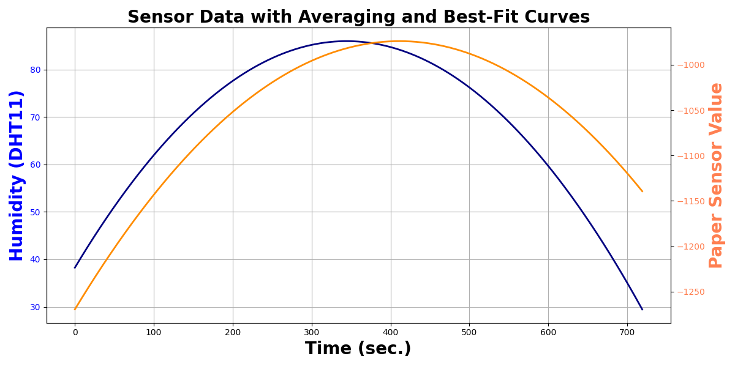
- Test 2: (Hand Made paper)
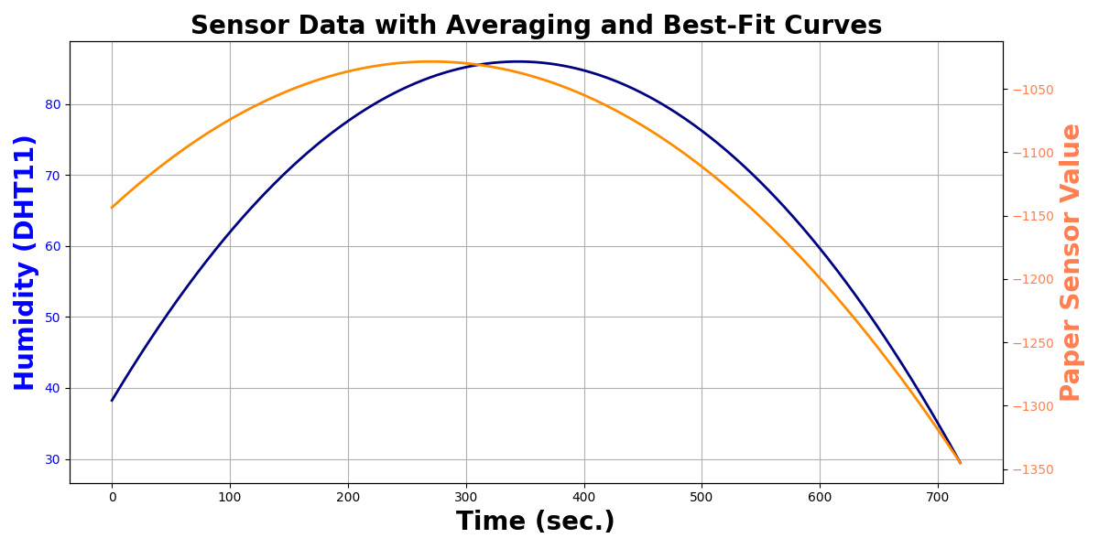
- Test 3: (Hand Made paper)
